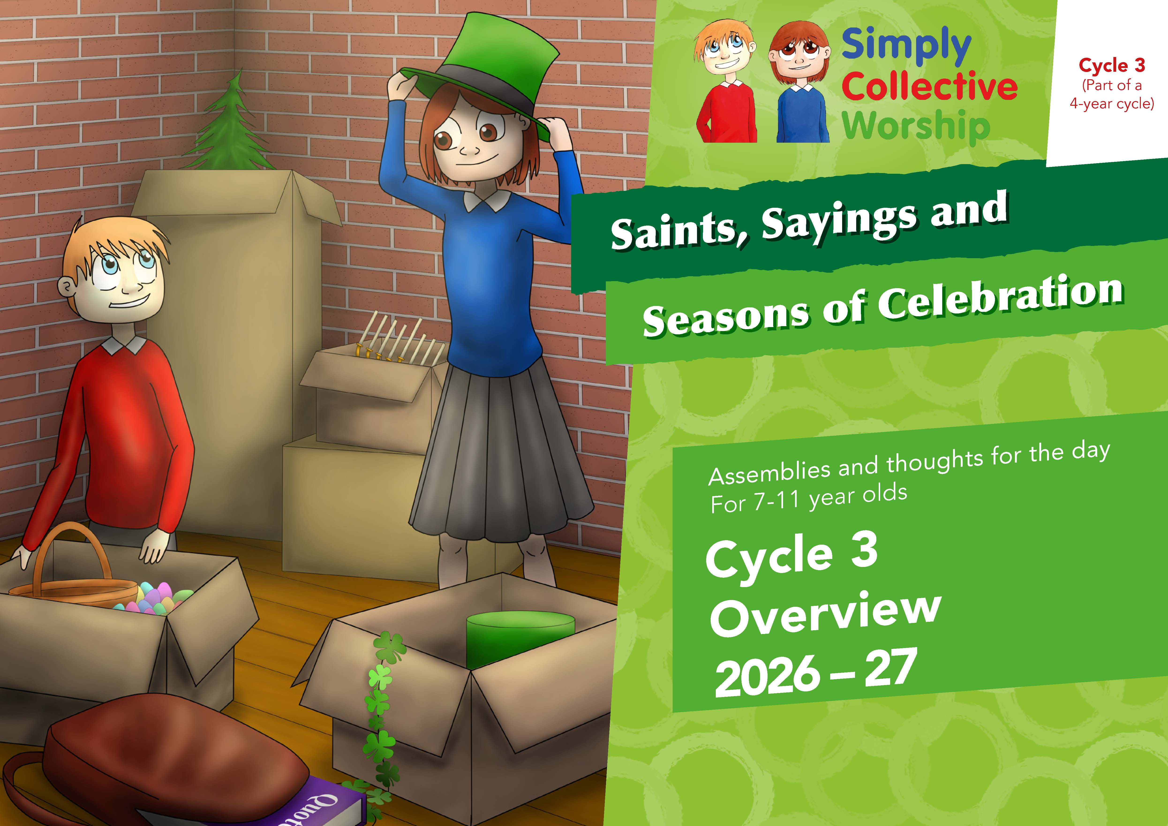


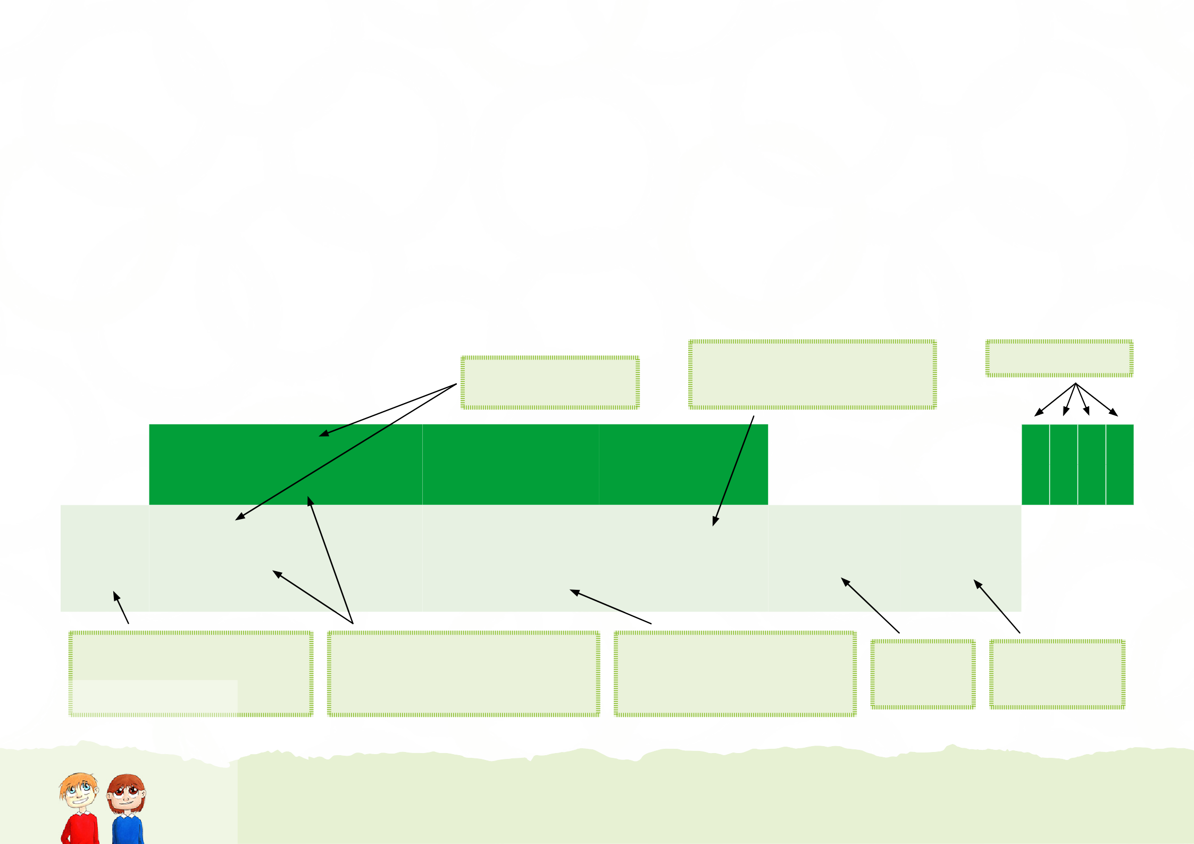
Aims:
- To provide a four-year scheme that will support primary schools to develop important individual and community values whilst meeting the statutory requirements to provide daily acts of collective worship.

The Resource:
- Each week has an overall theme.
- Each week has one larger ‘assembly’, designed for a gathering of the whole school.
- Each week has four smaller ‘thought for the day’ or reflections, these are suitable for Key Stage 2 but can be adapted for Key Stage 1 / Foundation Phase.

The Overview:
✓

✓

✓

✓

Kindness Friendship

Being a really good friend

1.1 Non-verbal welcomes from around the world
1.3 When words can help or hurt

1.1-5 Various proverbs about words 1.1 Prov 12:13; 16:24;
18:4 1.2: 12:13;15:1; 11:12; 15:4;
11:17 1.3: 10:18; 11:13; 26:20
1.4: 27:6; 29:5. 1.5: 26:33
- Greetings
- Kind words
- Gossip
- Flattery friends
- Feedback or flattery
1
5th – 9th Sept ‘26
.2-5 Thought for the day

Values

Links to SEAL

Other Content

Supporting Statutory Requirements
.1 Main assembly/theme
Week
*Suggested dates 2022-23

Title of the weekly theme and the main assembly.
Spiritual Moral Social
Cultural
Information not obvious in the theme/title and other notable stories and events are included here.
SMSC development




Suggested week and date, these can be changed to suit your school.
*The dates suggested may not correspond with the LA term dates 2022-23.
Four ‘thoughts for the day’, to be used in the classroom or smaller group settings.
Can be used as a short reflection in a larger celebration assembly.
Meeting statutory requirements – written within the context of pupils’ experience, to support and develop individual and community values.

Links to the half-termly SEAL theme.

Values included in the weekly theme (not exhaustive).



Theme*  Suggested dates  2022-23 | .1 Main assembly/theme | Supporting Statutory Requirements | Other Content | Links to SEAL | Values | Spiritual | Moral | Social | Cultural
Theme*  Suggested dates  2022-23 | .2-5 Thought for the day
1  1st – 4th Sept ‘26 | - Greetings  - Kind words  - Gossip  - Flattery friends  - Feedback or flattery | 1.1-5 Various proverbs about words 1.1 Prov 12:13; 16:24; 18:4 1.2:  12:13;15:1; 11:12; 15:4; 11:17 1.3:  10:18; 11:13; 26:20 1.4: 27:6; 29:5.  1.5: 26:33 | 1.1 Non-verbal welcomes from around the world  1.3 When words can help or hurt | Being a really good friend | Kindness Friendship | ✓ | ✓ | ✓ | ✓
2  7th – 11th Sept ‘26 | - Hello and welcome  - Welcoming Thomas  - Unwelcome first impressions  - Familiar welcome  - Welcome and unwelcome |  | 2.1 Hello in different languages  2.1-4 ‘Thomas’ – a story about starting a new school  2.5 Rules for discussing sensitive issues | Making someone feel welcome | Kindness |  | ✓ | ✓ | ✓
3  14th – 18th Sept ‘26 | - Democracy Day  - Local King  - Parliament  - Vote for all  - A good debate |  | 3.1 Definition of words associated with democracy in the UK  3.2-4 History of democracy in the UK |  | Fairness Respect |  |  | ✓ | ✓
4  21st – 25th Sept ‘26 | - Gideon  - What might the neighbours say?  - Laying a fleece  - Gideon’s 300  - The trumpet call | 4.1-5 The story of Gideon |  | Doing something brave | Courage Friendship | ✓ |  | ✓
7*  28th Sept – 2nd Oct ‘26 | - Sukkot  - Sukkah  - Lulav and etrog  - Celebrate wisdom  - Wise sayings | 7.1 Leviticus 23:39-43 – Rules for Sukkot  7.5 Various quotes from Ecclesiastes | 7.1 Sukkot – Jewish festival of shelters  7.5 “A time for everything under the sun” |  | Respect | ✓ |  | ✓ | ✓
5  5th – 9th Oct ‘26 | - Francis of Assisi  - Saint Francis and the birds  - Saint Francis and the wolf  - Saint Francis and actions  - Two crabs | 5.4 Remove the wood from your own eye – Matthew 7:3-5 | 5.5 Aesop’s ‘Two Crabs’ |  | Courage  Joy | ✓ | ✓ |  | ✓
6  12th – 16th Oct ‘26 | - Hannah the harvest mouse  - Plough, sow and harvest  - Plough, sow and harvest (by hand)  - Threshing and winnowing  - You reap what you sow |  | 6.1 Hannah the Harvest Mouse and Farmer Goody  6.3 Jane ‘growing her own wheat by hand’  6.5 the general principle of sowing and reaping | Setting Goals | Kindness Friendship | ✓ |  |  | ✓
8  19th – 23rd Oct ‘26 | - Mr Everest  - Radhanath Sickdhar  - Edmund Hilary and Tenzig Norgay  - Altitude  - Team Work |  | 8.1 Highest mountains in the home nations & a short biography of Sir George Everest | Setting Goals | Determination Teamwork |  |  | ✓ | ✓


Autumn 1
* The numbers correspond to the order of the themes in Cycle 3.

Theme*  Suggested  dates  2022-23 | .1 Main assembly/theme | Supporting Statutory Requirements | Other Content | Links to SEAL | Values | Spiritual | Moral | Social | Cultural
Theme*  Suggested  dates  2022-23 | .2-5 Thought for the day
9  2nd – 6th Nov ‘26 | - Off with a bang!  - Firework facts  - Firework world records  - A sparkling fact  - The fireworks code |  | 9.1 History and development of Fireworks  9.3 Facts about sparklers and safety tips when using them |  | Joy |  |  |  | ✓
10  9th - 13th Nov ‘26 | - Truce (Remembrance)  - Giving peace  - Peaceful actions  - Peace belongs to all of us  - Blessed are the peacemakers | - May the Lord of peace give you peace – 2 Thessalonians 3:16  - If you want to enjoy life… 1 Peter 3:10-11  10.3 Blessed are the peacemakers – Matthew 5:9 | 10.1 Brief background to WW1 | Getting on and falling out | Respect Peace Liberty | ✓ | ✓ | ✓ | ✓
11  16th – 20th Nov ‘26 | .1 Pack up your troubles  .2 SS Laurentic  .3 Troubles  .4 Lamentations  .5 Packing up the right troubles | 11.4 Opening verses from the book of Lamentations | 11.1,2,3,4,5 Story of the 1915 song ‘Pack up your Troubles’  Search of SS Laurentic’s Gold |  | Courage Determination Liberty |  | ✓ | ✓ | ✓
12  23rd – 27th Nov ‘26 | - The power of a few letters  - Teamwork doesn’t just happen  - Helping a teamwork  - Listening  - .5 Two’s company, three’s a crowd | 12.3 Two people are better off than one – Ecclesiastes 4:9-10 | 12.1 History of ‘our alphabets’ | Working collaboratively | Friendship  Respect  Democracy |  |  | ✓ | ✓
13  30th Nov – 4th Dec ‘26 | - The ladybird and Our Lady  - Ladybird’s spots of joy  - What’s in a name?  - Kind words bring life  - Prince of peace | 13.1 Mary and Elizabeth – Luke 1:26-38 & Isaiah 9:6-7  13.2 Mary – Luke 1:39-45 & 48  13.4 Kind words bring life – Proverbs 15:4 | 13.2 Seven Joys and Seven Sorrows of Mary | Getting on and falling out | Kindness Peace Forgivenss | ✓ |  | ✓ | ✓
14  7th – 11th Dec ‘26 | - Peace on earth and goodwill to men  - Goodwill to all  - Inner peace on Earth  - Peace on Earth and peace in here!  - Peace out | 14.1 The Shepherds account of the Nativity | 14.3 Devices can mess with our body’s natural rhythm  14.4 ‘Benefits of’ and ‘how to take a time out’ also in 14.5 | Getting on and falling out | Friendship Peace | ✓ |  | ✓
15  14th – 18th Dec ‘26 | - Nativity art  - Mary  - Joseph  - Shepherds  - Wise Men | Various pieces of fine art are suggested to explore the themes of the Nativity |  |  | Joy | ✓ |  |  | ✓

Autumn 2
* The numbers correspond to the order of the themes in Cycle 3.

Theme*  Suggested  dates  2022-23 | .1 Main assembly/theme | Supporting Statutory Requirements | Other Content | Links to SEAL | Values | Spiritual | Moral | Social | Cultural
Theme*  Suggested  dates  2022-23 | .2-5 Thought for the day
16  4th – 8th Jan ‘27 | - Traditional New Year  - England  - Ireland  - Scotland  - Wales |  | New year’s traditions from:  - around the world  - England  - Ireland  - Scotland  - Wales | Setting and achieving goals | Joy | ✓ |  | ✓ | ✓
17  11th – 15th Jan ‘27 | - Resolution Resolve  - The path  - The rocky soil  - The thorns  - The good soil | 17.1-5 Parable of the sower – Matthew 13:1-23 |  | Setting and achieving goals | Determination | ✓ | ✓ | ✓
19*  18th – 22nd Jan ‘27 | - Martin Luther King  - Sticks and stones  - The tongue  - Stephen and Georgia  .5 Gossip | 19.2 Thoughtless words – Proverbs 12:13  19.3 Power of the tongue – James 3:3-6  19.5 Ensure your servant’s well- being – Psalms 119:121-122 | 19.1 The account of Rosa Parks and a short biography of MLK  19.4 Story of Stephen and Georgia | Resilience – bouncing back or maintaining effort | Resilience  Fairness | ✓ |  | ✓ | ✓
18  25th – 29th Jan ‘27 | - Resolution Foundation  - The wise builder  - The foolish builder  - Parable of the wise piano player  - Practise makes perfect | 18.1 Parable of the wise and foolish builders – Matthew 7:27- 27 | 18.1 & 4 Parable of the wise and foolish piano players | Resilience – bouncing back or maintaining effort | Determination | ✓ | ✓ | ✓
21*  1st – 5th Feb ‘27 | .1 Lenten tradition  .2 Omelette Day  .3 King cake  .4 Dia de la Samaritana  .5 Celebration through action |  | 21.1 History of the pretzel |  | Forgiveness |  |  | ✓ | ✓

Spring 1
* The numbers correspond to the order of the themes in Cycle 3.

Theme*  Suggested  dates  2022-23 | .1 Main assembly/theme | Supporting Statutory Requirements | Other Content | Links to SEAL | Values | Spiritual | Moral | Social | Cultural
Theme*  Suggested  dates  2022-23 | .2-5 Thought for the day
20*  15th – 19th Feb ‘27 | - Wellbeing Resolution  - Well-being checklist  - Well-being checklist  - In thought, word and deed  - Community of well-being | 20.1 Ensure your servant’s well- being – Psalms 119:121-122  20.5 Encourage and build up – Thessalonians 5:11 | 20.2-3 Well-being checklist | Waiting for what they want, persistence | Happiness Peace | ✓ |  | ✓
24*  22nd – 26th Feb ‘27 | - Easier isn’t always easy  - Others find it easier  - Practise  - Resilient mistake  - Comfort zone |  | 24.1 Even the English coordinator needs to practice her/his reading  24.5 Poem ‘My Comfort Zone’ | Good to be me | Determination Courage |  | ✓ | ✓
22*  1st – 5th  Mar ‘27 | - Dewi Sant (St David) (1st March)  - “Do the little things”  - Can you be trusted with very little?  - Can you be trusted with the small things?  - Celebration | 22.2 Do not despise the day of small beginnings – Zechariah  4:10 Whoever can be trusted… – Luke 16:10 | 22.1 Definitions of Britain, UK and British Isles | Doing something to be proud of | Joy Friendship | ✓ | ✓ | ✓ | ✓
25*  8th – 12th  Mar ‘27 | - St Patrick – bouncing back (17th March)  - The king and the fire festival  - St Patrick drives the snakes from Ireland  - The Shamrock  - Practise setbacks | 25.5 Facing trials – James 1:1-2 |  | Responding in an assertive way | Determination Friendship | ✓ | ✓ | ✓ | ✓
27*  15th – 19th Mar ‘27 | - Easter art  - Triumphal entry  - The Last Supper  - Jesus is arrested/crucifixion  - Resurrection | Various pieces of fine art are suggested to explore the events that took place during Holy-week  – the week before (and including) Jesus’ resurrection |  |  | Forgiveness | ✓ |  |  | ✓

Spring 2
* The numbers correspond to the order of the themes in Cycle 3.

Theme*  Suggested  dates  2022-23 | .1 Main assembly/theme | Supporting Statutory Requirements | Other Content | Links to SEAL | Values | Spiritual | Moral | Social | Cultural
Theme*  Suggested  dates  2022-23 | .2-5 Thought for the day
26  5th – 9th  Apr ‘27 | - Water day (22nd March)  - Walking for water  - Drinking dirty water  - Kofi  - Safe Water |  | 26.2 Short biography of Thomas Hawksley |  | Respect Fairness |  | ✓ | ✓ | ✓
23*  12th – 16th Apr ‘27 | - Balaam’s anger issues  - Calm people aren’t easily angered  - Calm people say nice things  - Patience brings peace  - A wise person can cool it | 23.1 Account of Balaam’s and his donkey  Proverbs about anger:  23.2 Proverbs 19:11  23.3 Proverbs 15:1  23.4 Proverbs 15:18  23.5 Proverbs 29:11 |  | Stopping and thinking when we’re angry | Peace | ✓ | ✓ | ✓
28  19th – 23rd Apr ‘27 | - Horology  - The church bell  - The minaret and the muezzin  - Time around the world  - Thinking time |  | 28.1 Development of clocks |  | Determination |  |  | ✓ | ✓
29  26th – 30th Apr ‘27 | - John Harrison  - Time for a change  - Horology hero  - An unsolvable problem  - Be inspired! |  | - 29.1-4 Biography of John Harrison | Being a good friend | Determination |  |  | ✓ | ✓
30  3rd – 7th  May ‘27 | - The Golden Rule  - The priest  - The good Samaritan  - Love thy neighbour – tolerance  - How can we love our neighbour? | 30.1 Love your neighbour – Leviticus 19:17  30.1-3 Parable of the Good Samaritan | 30.1 Golden Rule in a variety of belief systems  - Reference to the 2017 Manchester terror attack  Song Lyrics - When I needed a neighbour | Helping someone who is feeling sad or lonely | Respect Rule of Law | ✓ | ✓ | ✓ | ✓
38*  10th – 14th  May ‘27 | - Myths and legends  - The ballad of Thomas Rhymer  - The ballad of Thomas Rhymer  - Cormoran the giant  - Jack the giant killer |  | 38.1 The legend of March mab Meirchion |  | Courage |  |  |  | ✓
31  17th – 21st  May ‘27 | - Buddha Day (20th May)  - Heaven and hell  - Buddhist proverbs – words  - Buddhist proverbs – happiness and anger  - Buddhist proverbs – learning |  | 31.1 Biography of Siddhartha Gautama (The Buddha) | Changing an unfair situation | Respect Fairness | ✓ | ✓ | ✓ | ✓
32  24th – 28th May ‘27  * The numbers correspond to the order of the themes in Cycle 3. | - Cost the Earth – World Environment Day  - Give a man a fish  - Sustainable liberty  - Sustainable rules  - Assisi declarations |  | 32.1 ‘The Carob Tree’ | Changing an unfair situation | Respect Fairness |  | ✓ | ✓ | ✓
Summer 1

Theme  Suggested  dates  2022-23 | .1 Main assembly/theme | Supporting Statutory Requirements | Other Content | Links to SEAL | Values | Spiritual | Moral | Social | Cultural
Theme  Suggested  dates  2022-23 | .2-5 Thought for the day
33  7th – 11th June ‘27 | - Shavuot (10th June)  - Lighting of the candles  - Reading the Torah  - The Ten Commandments  - Respect Tradition | 33.1-5 Moses, the Passover, the Exodus and the Ten commandments  33.5 Obeying the law – Proverbs 28:7 | 33.1 Jewish festival of Shavuot | Coping with unexpected change | Respect | ✓ | ✓ | ✓ | ✓
34  14th – 18th June ‘27 | - Ruth  - Gleaning  - Kind Boaz  - Family  - A done deal, a wedding and a king | - The account of Ruth  - References to gleaning from Leviticus and Deuteronomy  34.5 Helping the poor – Proverbs 14:21 |  | Coping with unexpected change | Friendship Courage | ✓ | ✓ | ✓ | ✓
35  21st – 25th June ‘27 | - Time to flee – refugee (20th June)  - Time to flee from war and persecution  - Climate refugees  - Environmental refugees  - Time to flee through history |  | - Account of Udia from Syria  - YouTube ‘Most Shocking Second a Day’ |  | Kindness Respect Liberty |  | ✓ | ✓ | ✓
36  28th June – 2nd July ‘27 | - Positive change – Father Abraham  - Lot  - Father Abraham  - Three visitors  - Abraham and Isaac | 36.1 Account of Abraham, Lot and Sarah |  | Getting better at their learning | Courage | ✓ |  | ✓ | ✓
37  5th – 9th July ‘27 | - Watering the camels – Abraham 2  - How Camel got his hump  - The Djinn of the desert  - Camel’s humph  - Hardworking and kind camel | 37.1 Account of Eliezer finding a wife for Isaac | 37.2-5 Rudyard Kipling’s ‘How the Camel got his hump’ | Changing their behaviour for the better | Kindness | ✓ | ✓ | ✓ | ✓
39*  12th – 16th July ‘27 | - Memories (Leavers Assembly)  - A lasting journey  - A funny story  - The school motto  - Advising the future me |  | 39.1 Make good memories |  |  |  |  | ✓

Summer 2
* The numbers correspond to the order of the themes in Cycle 3.

