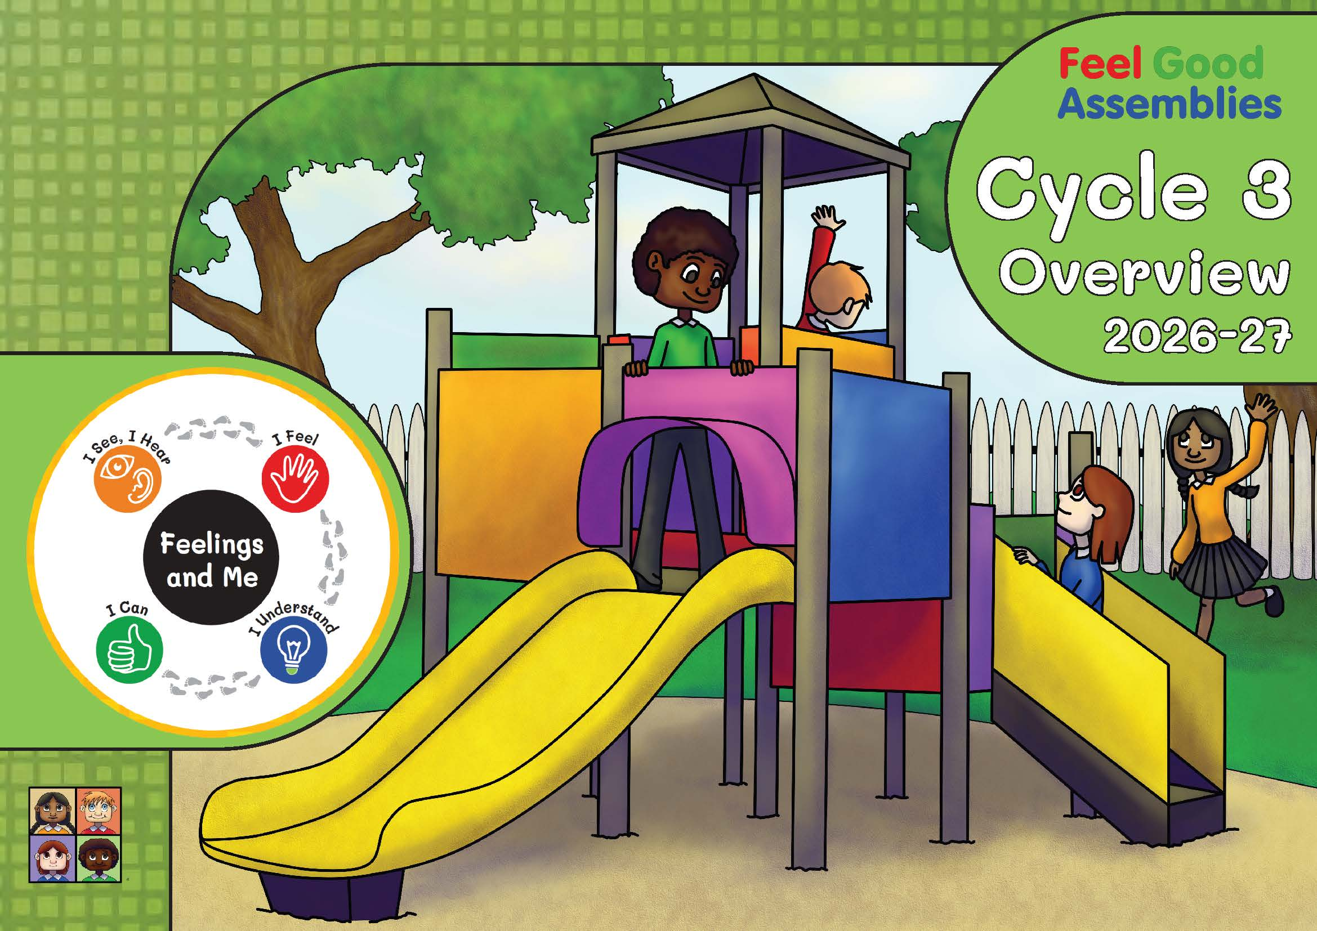

Theme  Suggested dates  2026-27 | Main assembly/theme | Feeling Focus | Subsidiary Focus
1  1st – 4th Sept ‘26 | Greetings | Happy and Sad | Feeling Welcome, Kindness
2  7th – 11th Sept ‘26 | Hello and Welcome  Thomas Starts a New School | Happy, Sad, Anger (annoyed) and Fear (scared/nervous) | Welcome, Kindness
3  14th – 18th Sept ‘26 | Democracy Day  Miss Williams and the Class Vote | Happy, Sad, Anger (annoyed) and Surprise | Democracy Day
4  21st – 25th Sept ‘26 | Gideon  A Sheepdog called Gideon | Happy, Sad, Anger, Fear, Surprise and Shame | Encouragement and being brave
7*  28th Sept – 2nd Oct ‘26 | Sukkot  Jamie and the Sukkah  Jess and the Lulav | Happy (excited) and Love | Thank you and Being Thankful
5  5th – 9th Oct ‘26 | Francis of Assisi  Saint Francis’ Dreams | Happy, Sad, Anger and Fear | The Natural World
6  12th – 16th Oct ‘26 | Hannah the Harvest Mouse (and farmer Goody) | Happy, Sad, Fear and Surprise | Harvest
8  19th – 23rd Oct ‘26 | Everest  Megan and the Mountains | Happy, Surprise (amazed) and Love | Awe and Wonder
Autumn 1
Copyright © 2026 Philip Lord
* The numbers correspond to the order of the themes in Cycle 2

Theme  Suggested dates  2025-26 | Main assembly/theme | Feeling Focus | Subsidiary Focus
9  2nd – 6th Nov ‘26 | Off with a Bang  Tommy Overcomes his Fear of Bonfire Night | Happy and Fear | Celebrations: Bonfire Night
10  9th - 13th Nov ‘26 | Remembrance Day | Remembrance Day | Peace, Quiet and Calm
11  16th – 20th Nov ‘26 | Pack up your Troubles  Lucas’ Hymn Singing | Happy and Sad | Perseverance
12  23rd – 27th Nov ‘26 | The Power of a Few Letters | Teamwork
13  30th Nov – 4th Dec ‘26 | The Ladybird and Our Lady  How the Ladybird got its Name  and Mary’s Surprise | Happy, Sad, Fear (worry) and Surprise | Advent
14  7th – 11th Dec ‘26 | Peace and Goodwill to Men  Lucas’ Goodwill to All | Happy, Sad and Fear (Worry) | Goodwill & Kindness
15  14th – 18th Dec ‘26 | Nativity Art | The Nativity
Autumn 2
Theme  Suggested dates  2025-26 | Main assembly/theme |  | Subsidiary
16  4th – 8th Jan ‘27 | Traditional New Year | New Year Traditions from around the World
17  11th – 15th Jan ‘27 | New Year’s Resolutions  The Sower, Seeds and Soil | Happy, Sad, Anger, Fear (Worry) and Anger | Determination
19*  18th – 22nd Jan ‘27 | Martin Luther King Jnr Day | Sad, Anger and Shame | Black History Month
18  25th – 29th Jan ‘27 | Wise and Foolish Builders  The Parable of the Piano Players | Happy (delight), Sad and Anger (frustration) | Practise, Determination and Resilience
21*  1st – 5th Feb ‘27 | Shrove Tuesday  Lucas’ Lenten traditions | Variations of Happy | Lenten Traditions
Spring 1
* The numbers correspond to the order of the themes in Cycle 2

Theme  Suggested dates  2025-26 | Main assembly/theme |  | Subsidiary
20*  15th – 19th Feb ‘27 | Choose Well-being  Jess says the Right Thing, Eventually | Feelings Pit Stop
24*  22nd – 26th Feb ‘27 | Easier Isn’t Always Easy  Abheek Learns to Ride a Bike | Variations of Sad | Resilience
22*  1st – 5th  Mar ‘27 | Dewi Sant (St David)  The Legends of St David | Variations of Surprise | Dydd Gŵyl Dewi, Saint David's Day
25*  8th – 12th  Mar ‘27 | St Patrick’s Day  St Patrick Bounces Back | Variations of Fear | St Patrick’s Day
27*  15th – 19th Mar ‘27 | Easter Art  Lucas and the Easter Story | Easter
Spring 2
* The numbers correspond to the order of the themes in Cycle 2
Theme  Suggested dates  2025-26 | Main assembly/theme
26  5th – 9th  Apr ‘27 | Water Day  Kofi’s Village Gets a Faucet (water tap) | Water Day | Water Stories from around the World
23*  12th – 16th Apr ‘27 | Balaam’s Anger Issues  Balaam’s Donkey | Variations of Anger
28  19th – 23rd Apr ‘27 | Time  Lucas’s Clocks | Variations of Love
29  26th – 30th Apr ‘27 | John Harrison  Time to Build a Boat | Resilience and determination
30  3rd – 7th  May ‘27 | The Golden Rule  The Good Samaritan | Happy (relief), Sad, Fear and Surprise | The Golden Rule
38*  10th – 14th  May ‘27 | Myths and Legends  King March mab Meirchion | A Good Story
31  17th – 21st  May ‘27 | Buddha Day  The Buffalo and the Monkey | Variety of Shame/Guilt | Wesak/Buddha Day
32  24th – 28th May ‘27 | Cost the Earth  Jess Plants an Acorn | Variations of Sad | World Environment Day
Summer 1
* The numbers correspond to the order of the themes in Cycle 2
Theme  Suggested dates  2025-26 | Main assembly/theme
33  7th – 11th June ‘27 | Shavuot  Jamie and the Cheesecake | Variations of Disgust | Festival of Shavuot
34  14th – 18th June ‘27 | Ruth | Feelings Pit Stop
35  21st – 25th June ‘27 | World Refugee Week  Jess, Jamie and Refugee Week | World Refugee Week | Timeout Strategies
36  28th June – 2nd July ‘27 | Positive Change  Father Abraham | Variations of Fear | Change
37  5th – 9th July ‘27 | Eliezer and Rebekah Watering the Camels | Kindness
39*  12th – 16th July ‘27 | Memories (Leavers/Transition Service)
Summer 2
* The numbers correspond to the order of the themes in Cycle 2

